**1.Try the Queue creation using Solace CLI**

**2.Use the pub-sub services created with Atin and try to populate the queue created using Solace CLI**

* **Start Putty [Solace CLI]:**

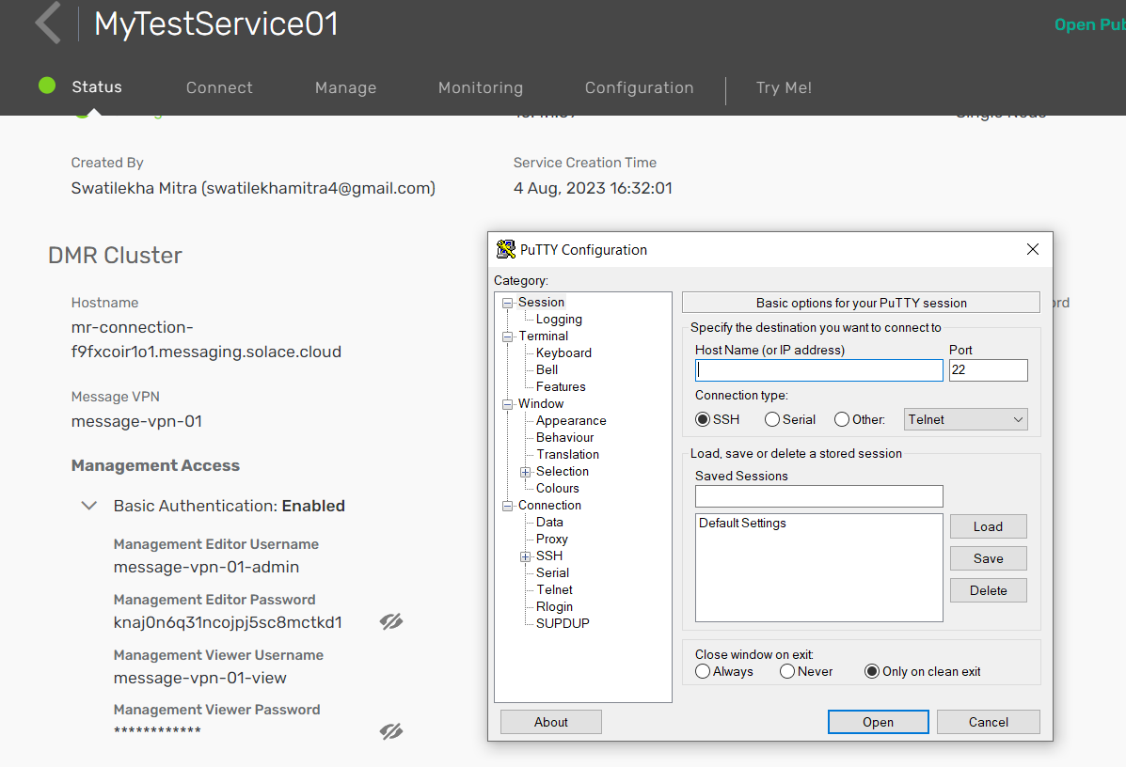

* **Check port number 22 is enabled or block...**

Manage --> Advanced Options --> Port Configuration --> edit --> Management.

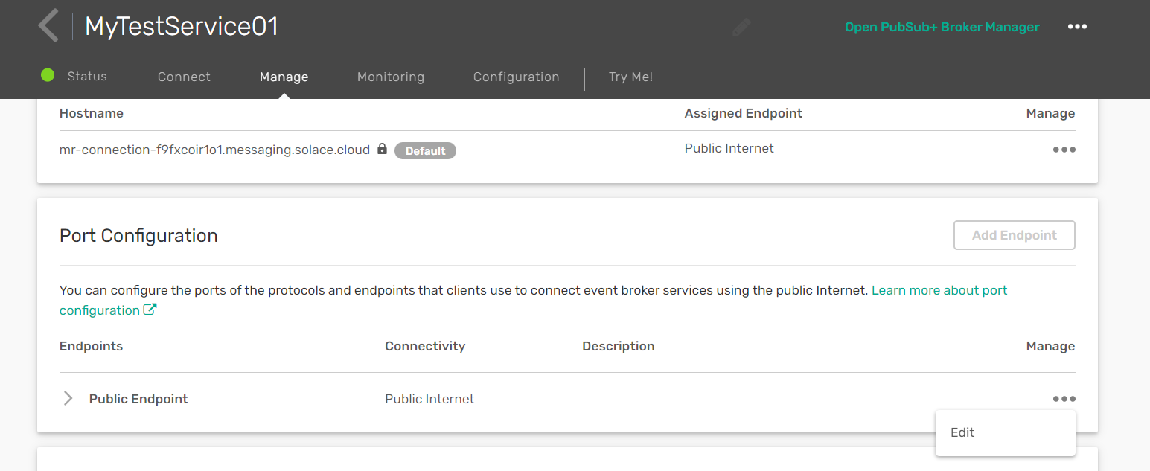

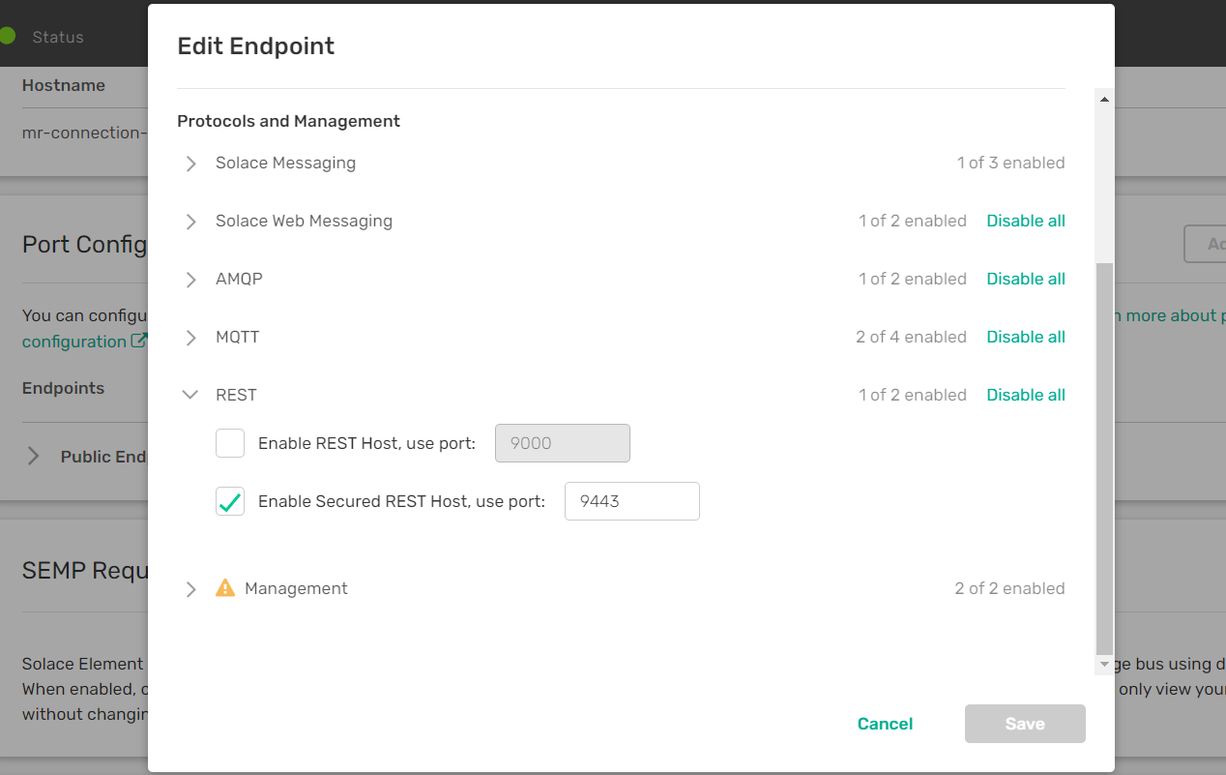

* **Enter Hostname and change some settings:**

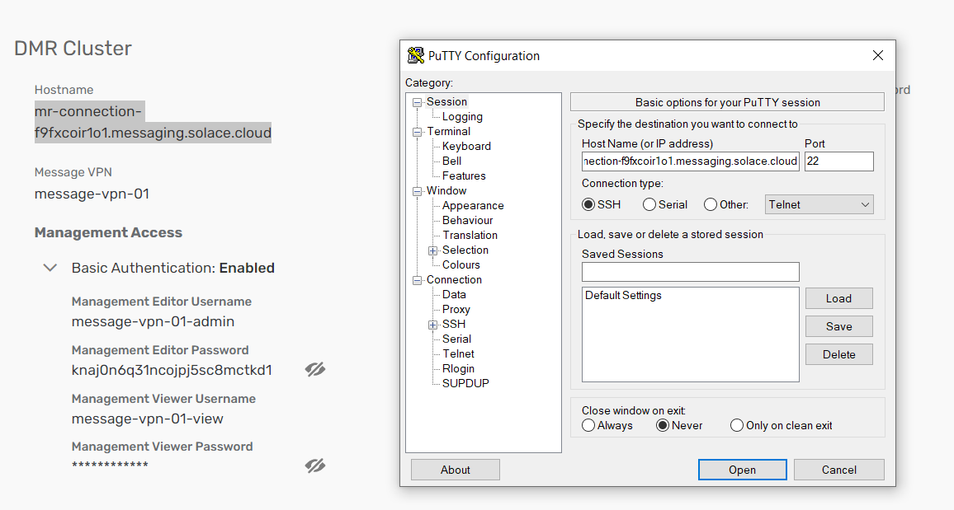

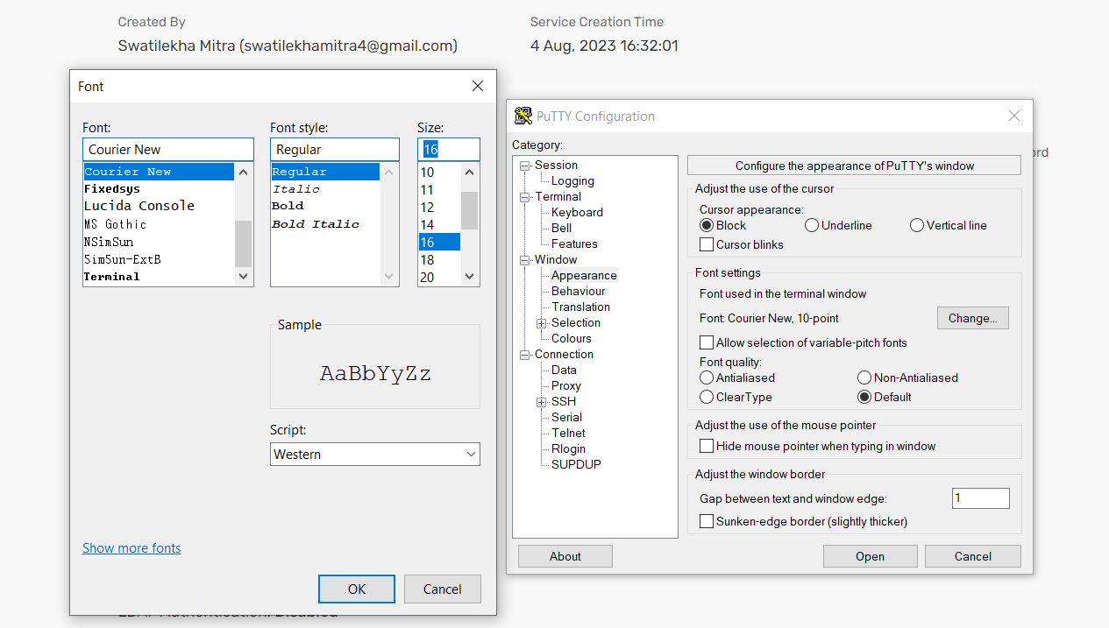

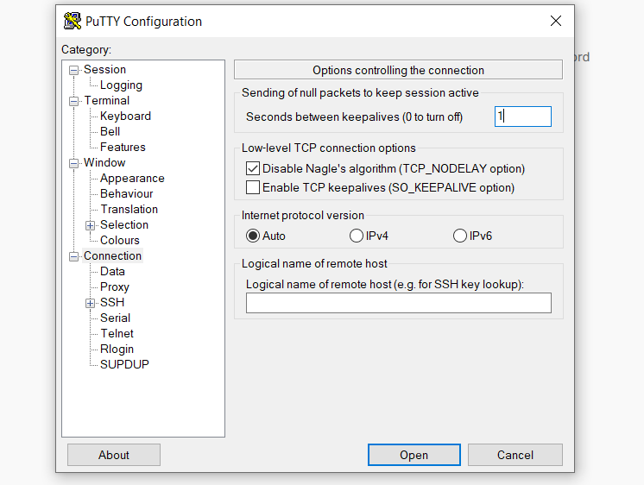

**Then, Open.**

* **Login with username and password:**

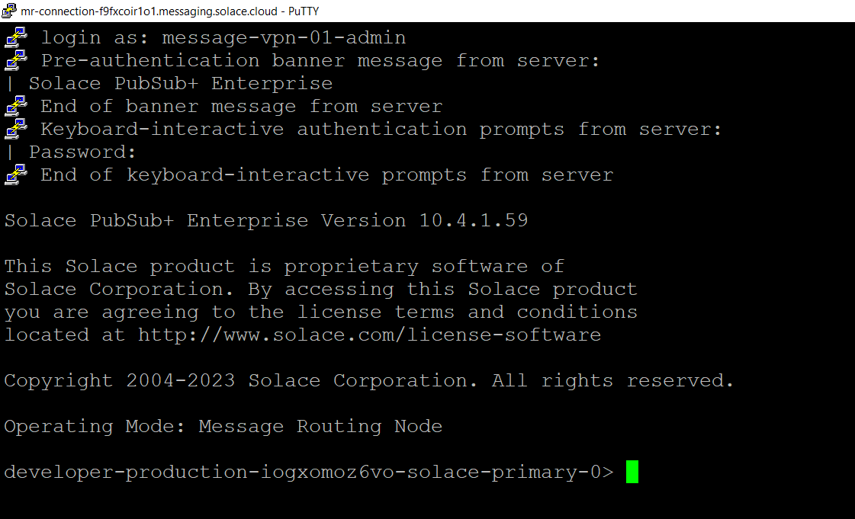

* **Create Queue with Subscription Topic:**

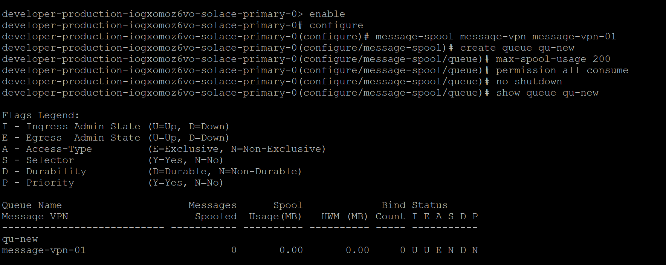

**Subscription Topic:**

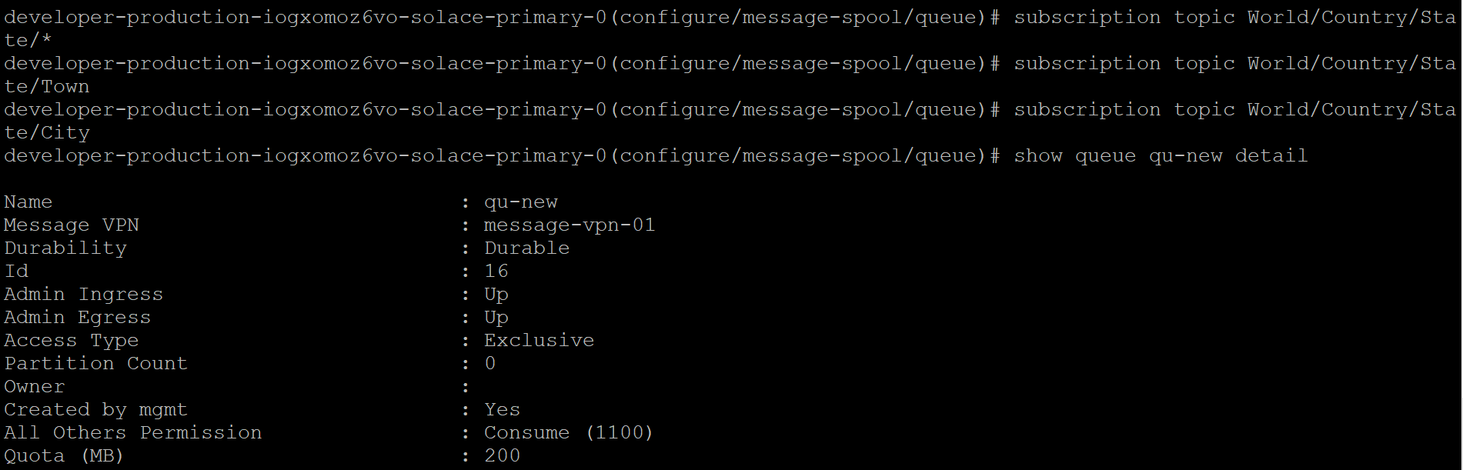

**Show The detail of Queue:**

**show queue qu-new detail**

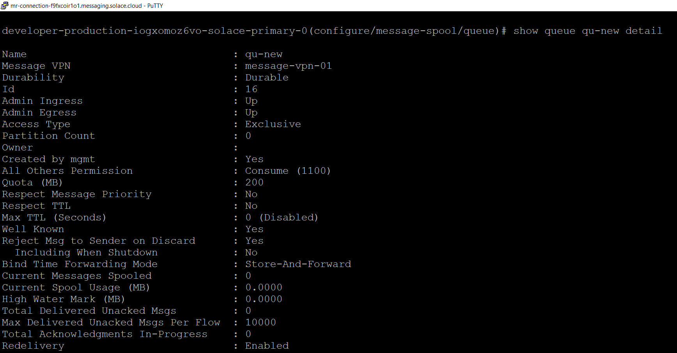

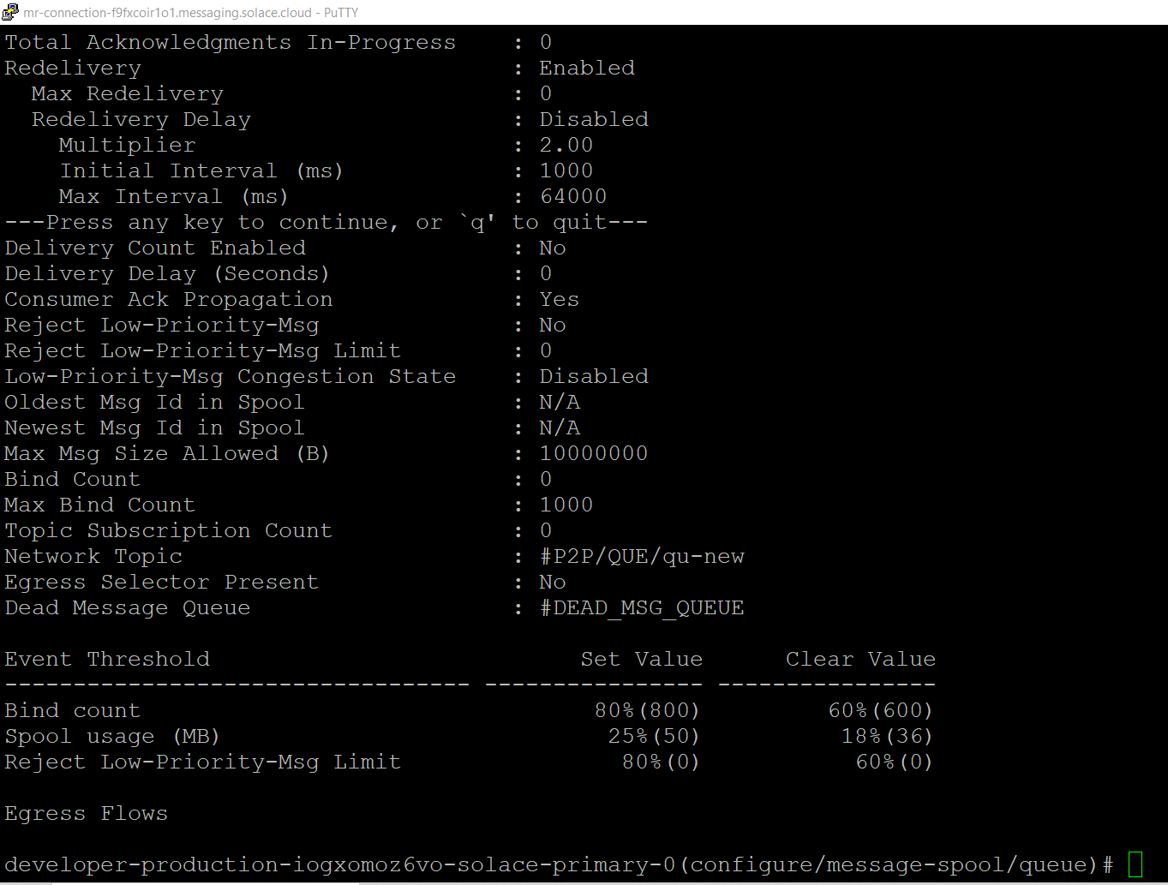

**Create new queue<qu-new> and subscription topic:**

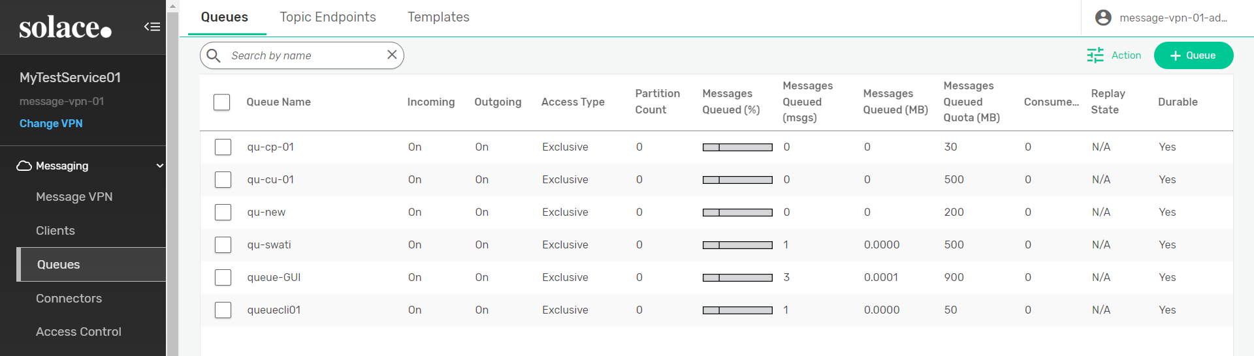

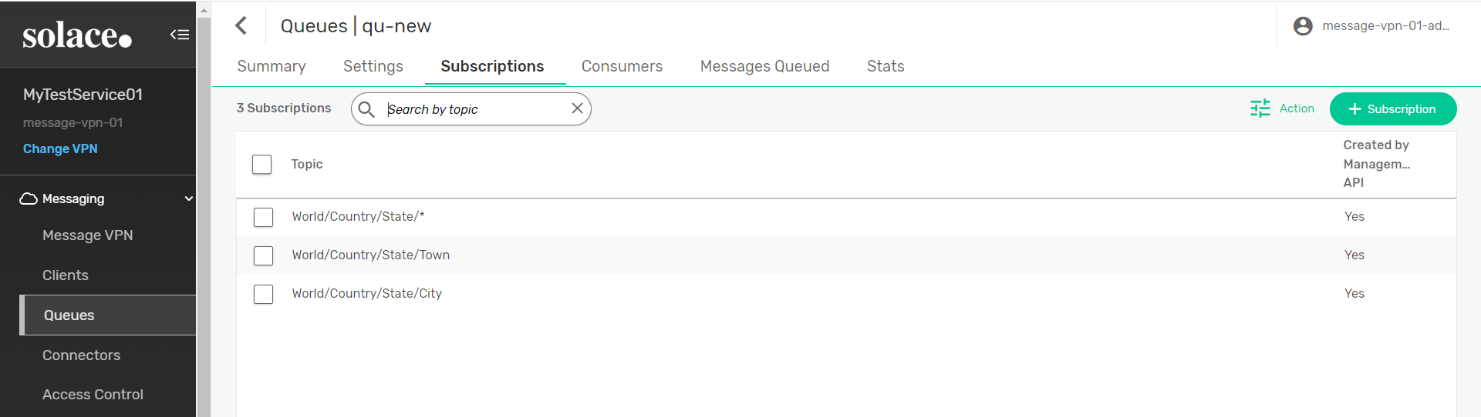

**Show Changes some settings of Queue:**

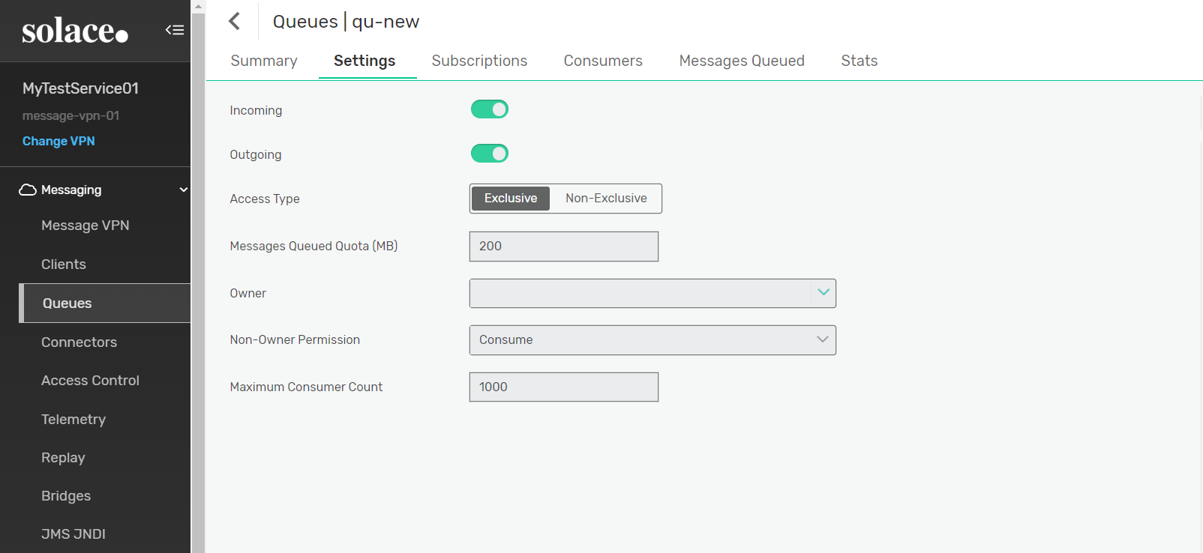

**Before executing the python code:**

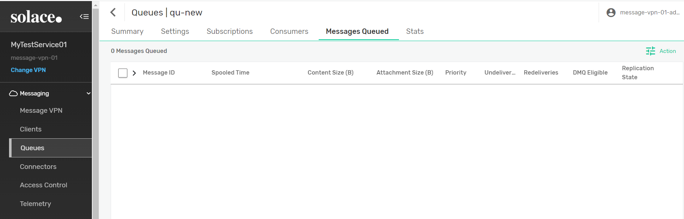

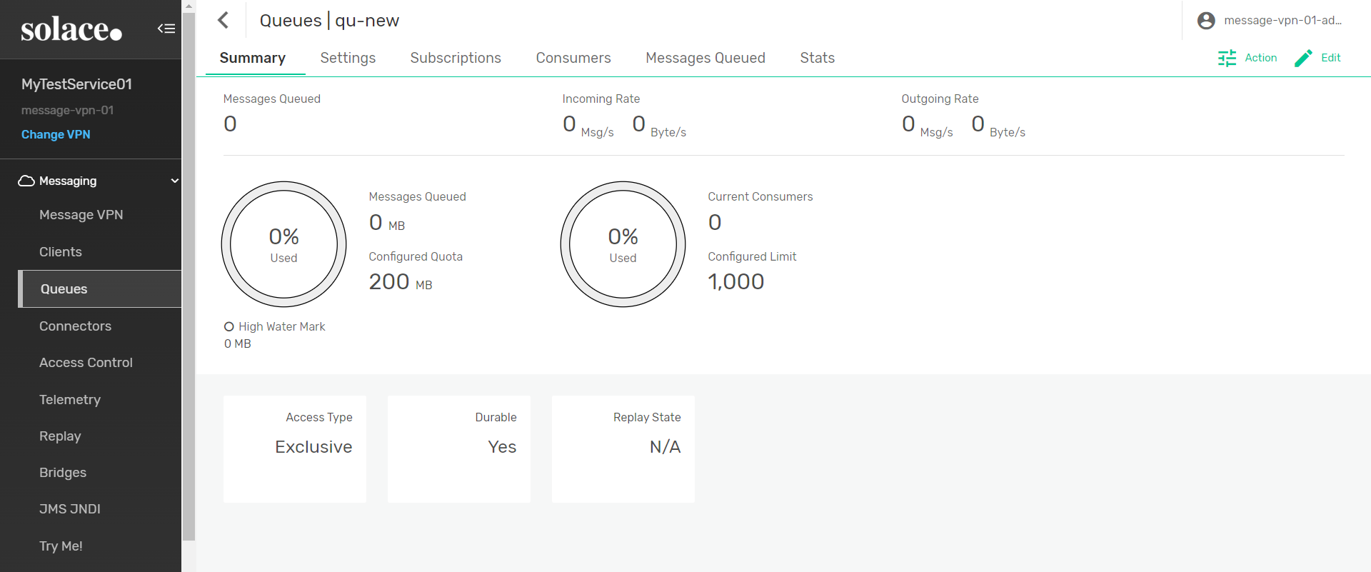

**Run the guaranteed_publisher.py code -**

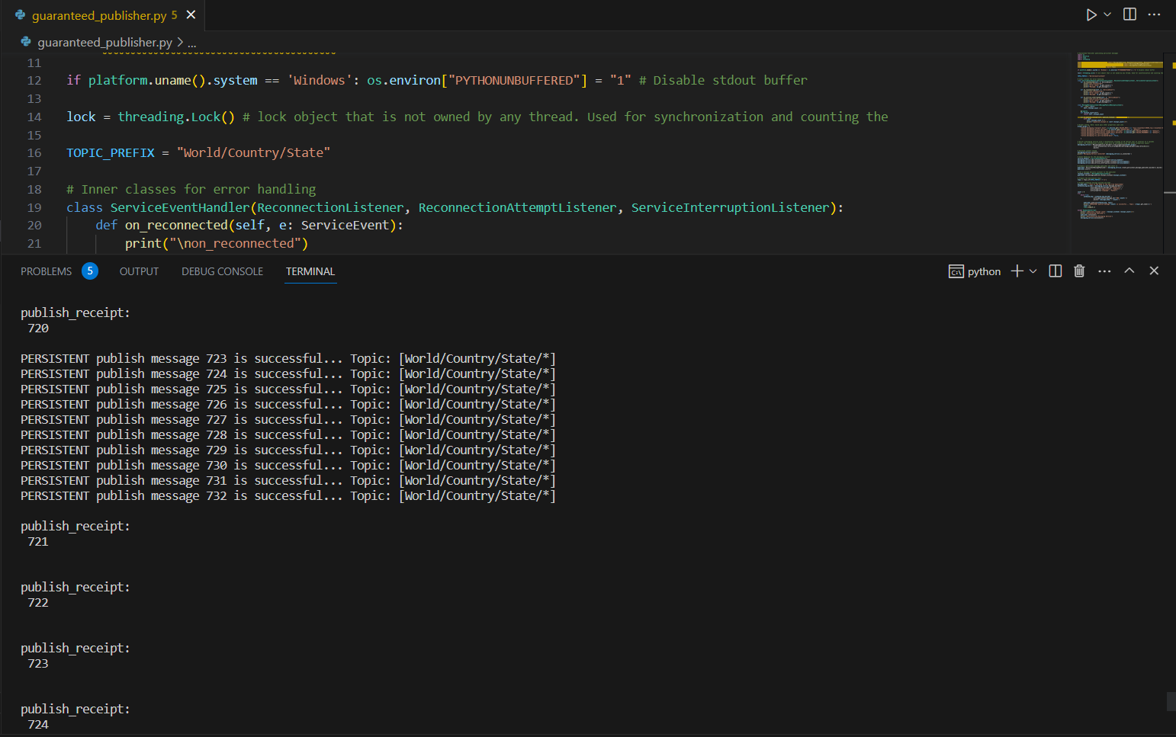

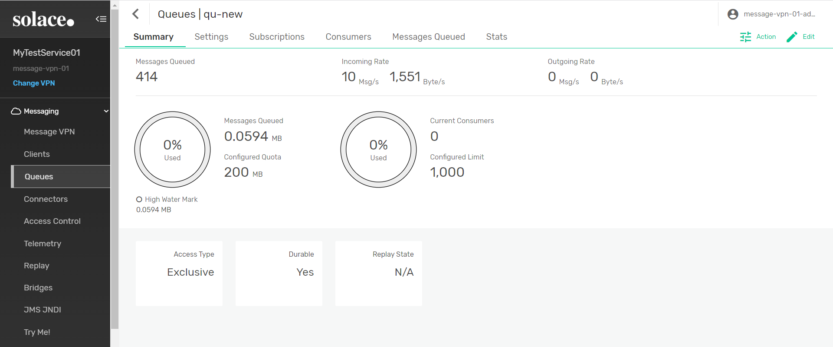

**Again, Refresh data and see Message Queued**

